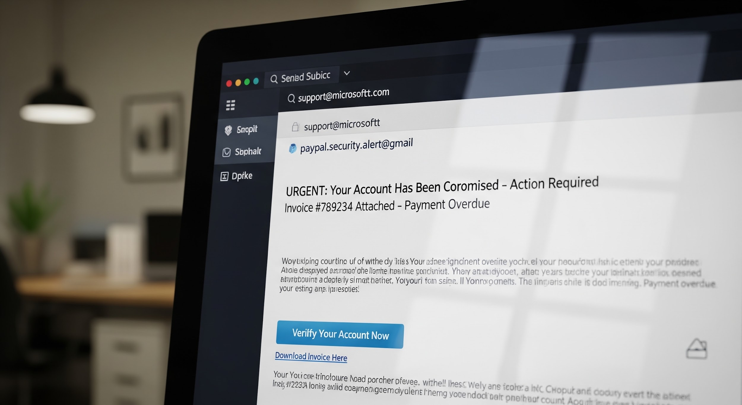

Part A (Case Study): Phishing
Phishing is a deceptive form of cyber fraud where attackers masquerade as a trustworthy entity in an electronic communication, typically an email, to trick a victim into providing sensitive data. This data includes usernames, passwords, credit card details, or other personal information.

How Phishing Happens
A typical phishing attack begins with a fraudulent email designed to look like it comes from a legitimate source, such as a major bank, a popular online service (like a streaming or e-commerce platform), or even a colleague. The email often contains an urgent and alarming message, such as "Your account has been compromised" or "Immediate action required to prevent service termination."

The core of the attack is a malicious link or an attached Filedocument. If the victim clicks the link, they are redirected to a convincing fake website that mirrors the legitimate one. Here, they are prompted to enter credentials or other personal details. For example, a fake bank login page will steal the user's username and password. Alternatively, an infected attachment can deploy malware onto the user's system to steal data silently. Successful phishing grants the fraudster unauthorized access, leading to financial loss or identity theft.

Who is Targeted
While large, high-value individuals and corporate employees are often targets of Spear Phishing—highly personalized attacks—mass-market phishing targets a very broad audience. Anyone with an email address or a smartphone is a potential victim.

Attackers often target individuals who are less technologically savvy, such as the elderly, or those who are busy and likely to click without thinking, like corporate workers responding to a fake IT alert. The most sought-after targets are individuals with access to valuable assets, including:

- Financial Account Holders: People with bank accounts or credit cards, to steal funds.
- Organizational Employees: To gain access to corporate networks, intellectual property, or customer data.
- Users of Cloud Services: People with accounts on platforms like Google, Apple, or Amazon, to hijack their digital lives.

Phishing attacks rely on human error and the psychological manipulation of fear and urgency to bypass technical security measures.

